1 Day 4 Wheels Tour
Highlight of this tour : Cultural experience, Amazing views, wildlife and authentic villages
Difficulty: Moderate
Departure: Daily at 8:30 AM
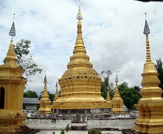

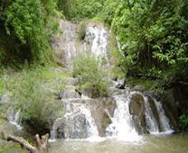

Trip Overview:
This scenic day will journey through the Nam Ha Protected area to Muang Sing. Choose a Tuk Tuk or Minivan to adventure on Journey the scenic jungle road.
We will visit unique villages. We will pass through beautiful nature, enjoying the lush mountains. Trained guides will share information about the ecology and culture.

Itinerary:
8:30 Am - Arrive to the office to prepare. 9:00 Am - Meet with guide and leave office by Tuk-Tuk for about 30 minutes
- On the way you will see mountains and enjoy beautiful scenery filled with streams, forests and minority villages (Hmong, Lantan, Khmu, Akha, Tailue and Taidam ethnic group.
- Around noon we will stop for lunch at the Pha Nguang waterfall. Accessible via the Kiew lom mountain pass.
- After that we will quickly descend into the Muang Sing valley with views of the mountains and rice paddy fields.
- Before we arrive in Muang Sing we will climb up to the Xieng Tueng stupa which is one of the most important Bhuddist stupa’s in the Muang sing district. Where if the times allows it we can enjoy a short coffee break at the stupa mountain lodge with views of the Muang sing valley.
- Continue to the Muang Sing town to visit the Museum and local market before returning to Luang Namtha
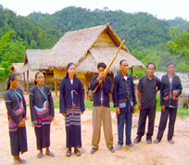

Things to Bring:
Please bring good walking shoes, long sleeve T-shirt, warm sweater, long pants, hat, sunscreen, mosquito repellents, camera, medicines, snack food, and money to purchase handicrafts.

Price includes:
Experienced guide, tour permit and village conservation fund, local government taxes, food, and first aid kit.

Price:

Amount of People | 2 | 3 | 4 | 5 | 6 | 7 | 8
Price/Kip | 450.000 | 430.000 | 400.000 | 370.000 | 350.000 | 330.000 | 300.000
Price/dollar | 54 | 52 | 48 | 44 | 41 | 37 | 35

Where does your Money go?

