1 Day Trekking - ½ Kayaking, ½ Trekking
Highlight of this tour : Mixed adventure, forest, amazing views, wildlife and authentic villages
Difficulty: Moderate
Departure: Daily at 8:30 AM

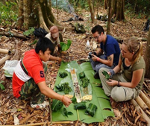

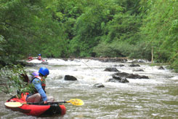

Trip Overview:
This challenging day will include 7-8 hours of walking in the Nam Ha Protected area. The trip will visit up to 5 unique villages. We will pass through beautiful nature, enjoying the lush mountains. Trained guides will share information about the ecology and culture. Time will be taken to explore ethnic villages and we will arrive on a mountain top with stunning views. We will learn about traditional crafts and engage with locals

Itinerary:
8:30 Am - Arrive to the office to prepare. 9:00 Am - Meet with guide and leave office by Tuk-Tuk for about 30 minutes

½ Day Trekking
You will walk slowly up through the primary forest, passing amazing views of Luang Namtha valley. Later this morning we will head deeper into the Namha Protected Area, where your local guide will teach you about the poisonous and edible plants, local herbal medicines, and how to spot wildlife on the way.
We will arrive at Namdee waterfall to enjoy a traditional picnic lunch, then a tuk-tuk will bring you to the kayak.

½ Day Kayaking

This Kayaking trip Ride from Soptud village offers you amazing landscapes of Riverbanks and the beautiful Nam Tha River. After 3 hours of kayaking on the Namtha river with whitewater rapids you will arrive at Gan-gnua jumping resort and stop for lunch and enjoy cable line jumping on Namtha river or refreshing swim.

Price

Amount of People | 1 | 2 | 3 | 4 | 5 | 6 | 7
Price/Kip | 750.000 | 450.000 | 430.000 | 410.000 | 380.000 | 350.000 | 320.000
Price/dollar | 92 | 54 | 50 | 48 | 44 | 41 | 37

Where does your Money go?

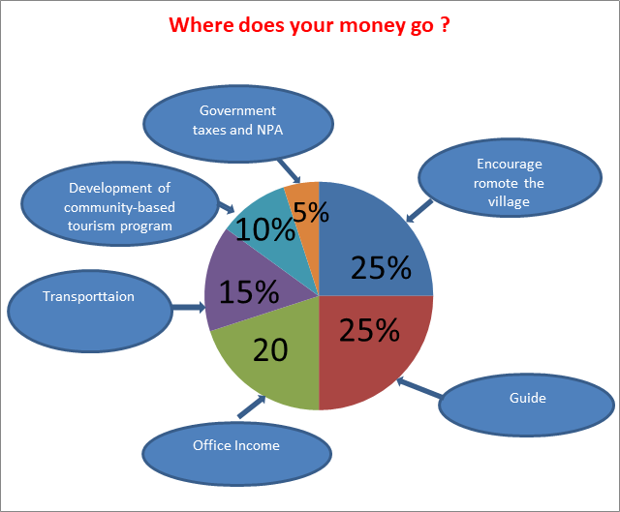

Things to Bring:
Please bring change of clothes, hat, sunscreen, mosquito repellents, camera,
medicines, snack food, and money to
purchase handicrafts.

Price includes:
Experienced guide, tour permit and village conservation fund, local government taxes, food, water and first aid kit.

