1 Day Trekking - Easy
Highlight of this tour : Primary forest, Amazing views, wildlife and authentic villages
Difficulty: Easy
Departure: Daily at 8:30 AM

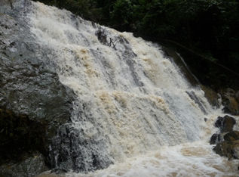
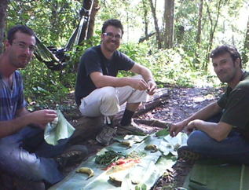

Trip Overview:
This unique loop trail will focus on the culture of the Lanten people. We will pass through beautiful nature, enjoying the lush mountains. Trained guides will share information about the ecology and culture. Time will be taken to explore multiple ethnic vilages and we will arrive on a mountain top with stunning views. We will learn about traditional crafts and engage with Sida and Khmu villages as well.

Itinerary:
8:30 Am - Arrive to the office to prepare. 9:00 Am - Meet with guide and leave office by Tuk-Tuk
- Walk for 2 hours through thick forest with a Lanten guide who will explain culture and customs.
- Arrive on the mountaintop with amazing views of the Nam Ha conservation area
- Stop and sit in the forest for traditional Lanten lunch
- Trek another 1.5 hours through primary forest to Namdee waterfall where you can swim
- Spend time in a Lanten village where they wear traditional clothing, with a possibility to see the people making handicrafts and bamboo paper
- Visit Sida and Khmu villages on the way back to town
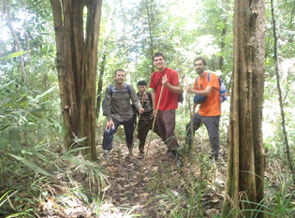

Things to Bring:
Please bring good walking shoes, long sleeve T-shirt, warm sweater, long pants, hat, sunscreen, mosquito repellents, camera, medicines, snack food, and money to purchase handicrafts.

Price includes:
Experienced guide, tour permit and village conservation fund, local government taxes, food, and first aid kit.

Price:

Amount of People | 2 | 3 | 4 | 5 | 6 | 7 | 8
Price/Kip | 300.000 | 280.000 | 260.000 | 240.000 | 220.000 | 200.000 | 180.000
Price/dollar | 36 | 33 | 30 | 28 | 26 | 23 | 21

Where does your Money go?

