1 Day Trekking - Moderate
Highlight of this tour : Primary forest, Amazing views, wildlife and authentic villages
Difficulty: Moderate
Departure: Daily at 8:30 AM

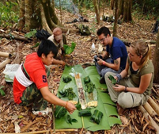
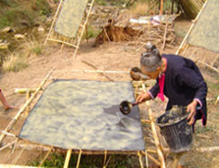

Trip Overview:
This challenging day will include 7-8 hours of walking in the Nam Ha Protected area. The trip will visit up to 5 unique villages. We will pass through beautiful nature, enjoying the lush mountains. Trained guides will share information about the ecology and culture. Time will be taken to explore ethnic villages and we will arrive on a mountain top with stunning views. We will learn about traditional crafts and engage with locals

Itinerary:
8:30 Am - Arrive to the office to prepare. 9:00 Am - Meet with guide and leave office by Tuk-Tuk for about 30 minutes
- In the morning we will walk for 2-3 hours through primary forest with Khmu tribe guide who will explain Khmu culture and customs, and find you some edible plants
- Next, arrive on the mountaintop with amazing views of the Nam Ha conservation area
- Stop and sit in the forest for traditional Khmu lunch
- After lunch, trek another 3-4 hours through primary forest
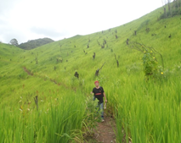
- Walk by jungle streams, and if you're lucky see wildlife

Things to Bring:
Please bring good walking shoes, long sleeve T-shirt, warm sweater, long pants, hat, sunscreen, mosquito repellents, camera, medicines, snack food, and money to purchase handicrafts.

Price includes:
Experienced guide, tour permit and village conservation fund, local government taxes, food, and first aid kit.

Price:

Amount of People | 2 | 3 | 4 | 5 | 6 | 7 | 8
Price/Kip | 400.000 | 330.000 | 350.000 | 320.000 | 300.000 | 270.000 | 250.000
Price/dollar | 36 | 33 | 30 | 28 | 26 | 23 | 21

Where does your Money go?

