2 Day Cycle and Kayak
Highlight of this tour : Two exciting ways to travel, diverse scenery, Amazing views, wildlife and authentic villages
Difficulty: Moderate
Departure: Daily at 8:30 AM

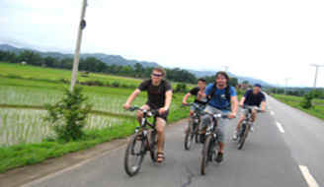

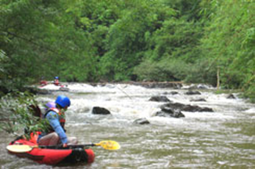

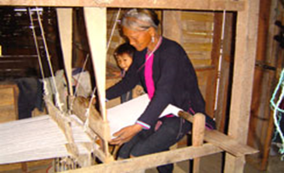

Trip Overview:
This trip combines cycling and kayaking. It is perfect for adventurers! You are able to see many different villages and beautiful nature! It’s your time to adventure! Truly experience the nature and local culture. Trained guides will share information about the ecology and culture. Time will be taken to explore ethnic villages. We will learn about traditional crafts and engage with locals.

Itinerary:
Day 1:
8:30 Am - Arrive to the office to prepare. 9:00 Am - Meet with guide and leave office
- Your first day you will cycle around Luang Namtha valley to see the different cultures and nature.
- The ride will include scenic views of the river bank, waterfall and visit minority villages (Hmong, Lantan, Khmu, Labed, Phounoi, Taidam and Akha ). You will travel on dirt roads and get away from busy areas.
- Visit Luang Namtha traditional museum to see local products (except weekends).
- Learn about traditional bamboo paper making (in winter), dying fabrics with plants as natural dyes, weaving, and how local Lao Lao whisky is made
- At night your guide will help prepare a local dinner. You will interact with villagers and relax. You will spend overnight in Bomphieng village, a Labit tribe village
After dinner we have Lao whisky preparing from your local guide for enjoy with together around campfire. Fall asleep with the sounds of the forest and village.
Day 2:
7:00 AM: You will wake up, and the guides will already have prepared your breakfast and lunch for you. When the weather is good you might be able to see or hear the wildlife
9:30 AM: After breakfast you will Trek fo a day. Today you will see more amazing scenery and interesting villages!
- Day 2 you will Kayak on the Nam Tha river, stopping at different Khmu and Lanten ethnic minority villages who live along the riverbank
-Travel through lush forests and beautiful scenery. See traditional villages.
- See the Nam Ha National Protected Area on the right hand side of the river and if you're lucky see some birds or animals
Your trip will finish around 3 pm on the main road where a Tuk - Tuk will bring you back.

Price:

Amount of People | 2 | 3 | 4 | 5 | 6 | 7 | 8
Price/Kip | 650.000 | 600.00 | 550.000 | 500.000 | 450.000 | 430.000 | 400.000
Price/dollar | 79 | 73 | 67 | 60 | 54 | 52 | 48

Where does your Money go?

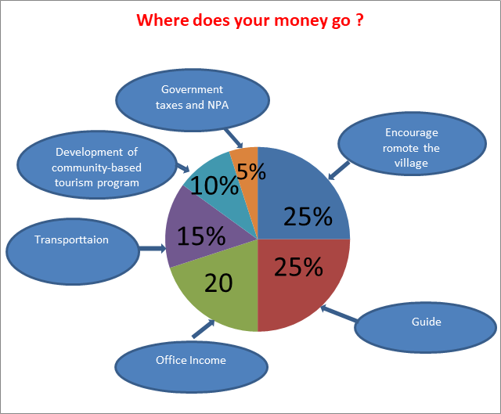

Things to Bring:
Please bring good walking shoes, long sleeve T-shirt, warm sweater, long pants, hat, sunscreen, mosquito repellents, camera,
medicines, snack food, and extra money.

Price includes:
Experienced guide, tour permit and village conservation fund, local government taxes, food, and first aid kit.

