2 Day Trekking - Lanten Homestay
Highlight of this tour : Homestay, forest, Amazing views, wildlife and authentic villages
Difficulty: Moderate
Departure: Daily at 8:30 AM

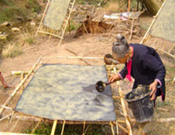

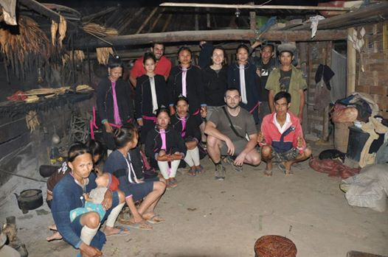

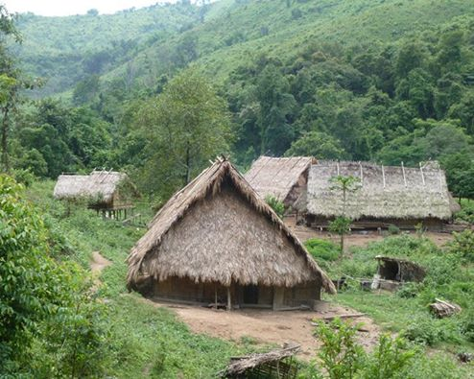

Trip Overview:
It’s your time to adventure! Embark on a 2-day trek and cultural experience. Truly experience the Lanten culture. Go up mountains with spectacular views of Luang Namtha, and through pristine forests to an overnight stay in the home stay. Experience traditional Lanten cooking and rice whisky. Walk throuhg Hmong and Khmu agricultural area. Trained guides will share information about the ecology and culture. Time will be taken to explore ethnic villages. We will learn about traditional crafts and engage with locals.

Itinerary:
Day 1:
8:30 Am - Arrive to the office to prepare. 9:00 Am - Meet with guide and leave office by Tuk-Tuk for about 30 minutes

After meeting with some of the villagers you will cross the Namtha river into primary forests for 2.5 hours. Your local guide will share his personal experiences with you and explain the customs and lifestyle of the Hmong tribe.
After trekking through the rubber forests, you will sit down for a traditional lunch and some fruit.
After lunch the journey continues through the forest for another 2 hours before arriving in the Lanten village called Ban Namla. This is where the first day of trekking ends and this village also has a small river to swim
After shower, you walk around the village, meet the villagers, play with the Lanten children. Use this opportunity to learn from their traditional practices of bathing, feeding animals and Lanten cooking as well as other ceremonial practices. Later on you will enjoy a dinner and drinking lao whisky with the village chief who will tell you about their history and customs, and maybe even help prepare a traditional dish.
Day 2:
8.00 AM: your are woken up by your guide and if you are not to tired we recommend you to walk around the village and see how Lanten people prepare for working in the field, feed the animals and learn from their ways of collecting water from the wells.
9:00 AM: After breakfast you will start walking along the Namla river for about 2.5 hours, before stopping for a traditional lunch in the jungle. After lunch you will continue your journey through the mountain with amazing views of the Hmong, Khmmu agriculture farm and cross to Namtha river hang bride. Your trekking will finish at Khmu village around 2 pm. where a Tuk - Tuk will bring you back to the office.

Price:

Amount of People | 2 | 3 | 4 | 5 | 6 | 7 | 8
Price/Kip | 750.000 | 700.000 | 650.000 | 600.000 | 550.000 | 500.000 | 450.000
Price/dollar | 91 | 85 | 79 | 73 | 67 | 60 | 54

Where does your Money go?

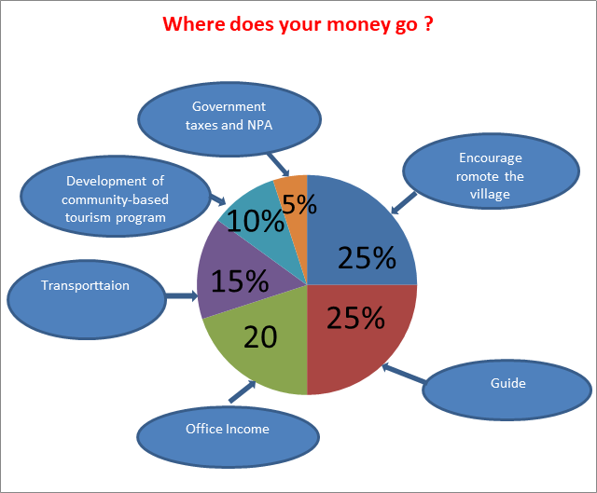

Things to Bring:
Please bring good walking shoes, long sleeve T-shirt, warm sweater, long pants, hat, sunscreen, mosquito repellents, camera,
medicines, snack food, and money to
purchase handicrafts.

Price includes:
Experienced guide, tour permit and village conservation fund, local government taxes, food, and first aid kit.

