2 Day Adventure Trek and Kayak
Highlight of this tour : Two exciting ways to travel, diverse scenery, Amazing views, wildlife and authentic villages
Difficulty: Moderate
Departure: Daily at 8:30 AM

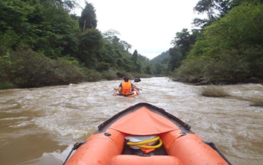
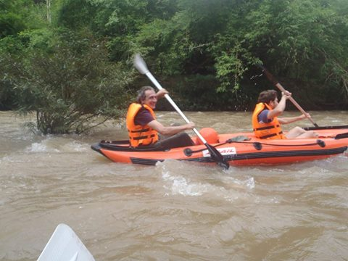

Trip Overview:
This trip combines two of our most popular activities. You are able to see many different things by kayaking and trekking! It’s your time to adventure! Truly experience the nature and local culture. Trained guides will share information about the ecology and culture. Time will be taken to explore ethnic villages. We will learn about traditional crafts and engage with locals.

Itinerary:
Day 1:
8:30 Am - Arrive to the office to prepare. 9:00 Am - Meet with guide and leave office by Tuk-Tuk for about 30 minutes
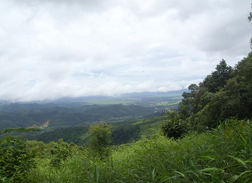
The trip includes one day trekking and then one day kayaking. Your first day will focus on trekking.
You will walk on steep up and down terrain in the Nam Ha National Protected Area for 3 hours before stopping for a traditional Lanten lunch. Enjoy the scenery and interact with locals along the way.
- After 3 hours more trekking, you'll arrive in Nam Lue village, which has both Khmu and Lanten people living in it
- You will stay with one of the families in the village and learn about their traditional practices of bathing, feeding animals and cooking as well as other ceremonial practices. After dinner we have Lao whisky preparing from your local guide for enjoy with together around campfire. Fall asleep with the sounds of the forest and village.
Day 2:
7:00 AM: You will wake up, and the guides will already have prepared your breakfast and lunch for you. When the weather is good you might be able to see or hear the wildlife
9:30 AM: After breakfast you will Kayak for a day downstream on the Nam Tha river. Amazing beautiful scenery!
-Stop at various Khmu and Lanten ethnic minority villages who live on the riverbank, observe their way of life and have the chance to purchase some local handicrafts. We will learn about Khmmu agriculture farm. Your trip will finish around 3 pm on the main road where a Tuk - Tuk will bring you back.

Price:

Amount of People | 2 | 3 | 4 | 5 | 6 | 7 | 8
Price/Kip | 750.000 | 700.000 | 650.000 | 600.000 | 550.000 | 500.000 | 450.000
Price/dollar | 92 | 87 | 81 | 75 | 68 | 62 | 58

Where does your Money go?

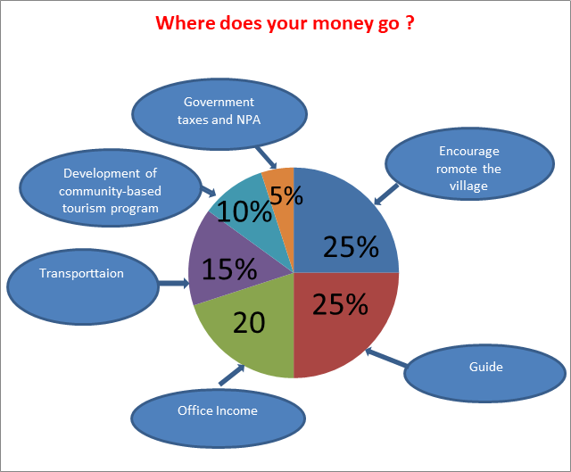

Things to Bring:
Please bring good walking shoes, long sleeve T-shirt, warm sweater, long pants, hat, sunscreen, mosquito repellents, camera,
medicines, snack food, and extra money.

Price includes:
Experienced guide, tour permit and village conservation fund, local government taxes, food, and first aid kit.

