2 Day Trekking - Waterfall Survival Camp
Highlight of this tour : Forest survival, Amazing views, wildlife and authentic villages
Difficulty: Moderate
Departure: Daily at 8:30 AM

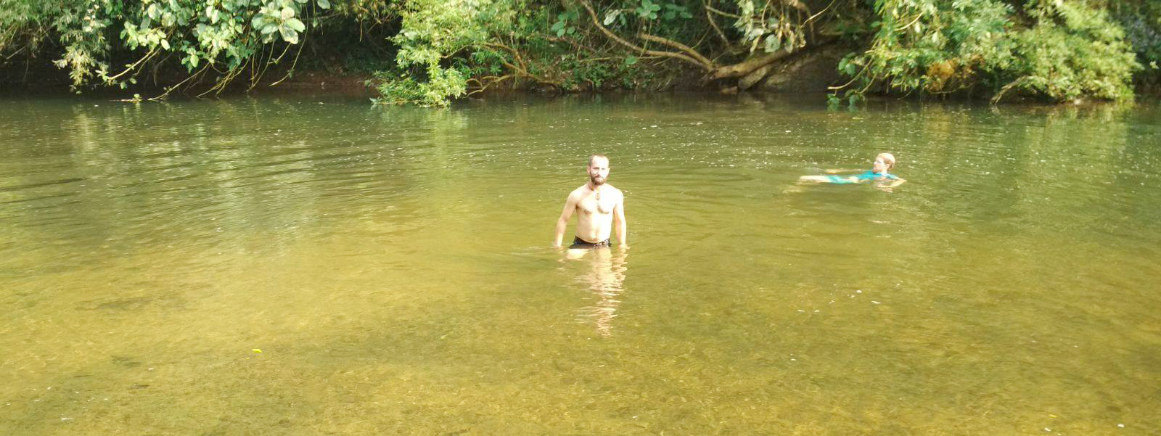

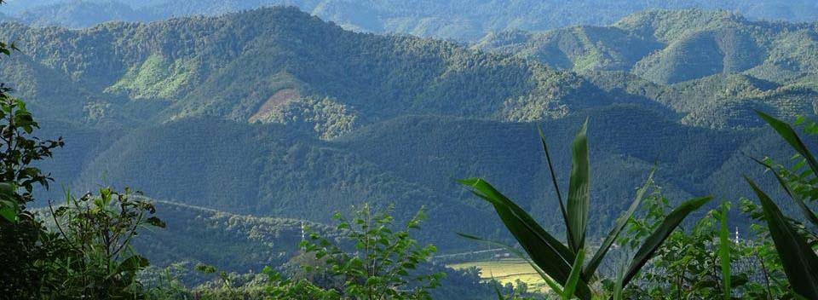

Trip Overview:
It’s your time to adventure! Embark on a 2-day trek and wilderness experience. Truly experience the nature and local culture. Trained guides will share information about the ecology and culture. Time will be taken to explore ethnic villages. We will learn about traditional crafts and engage with locals.

Itinerary:
Day 1:
8:30 Am - Arrive to the office to prepare. 9:00 Am - Meet with guide and leave office by Tuk-Tuk for about 30 minutes
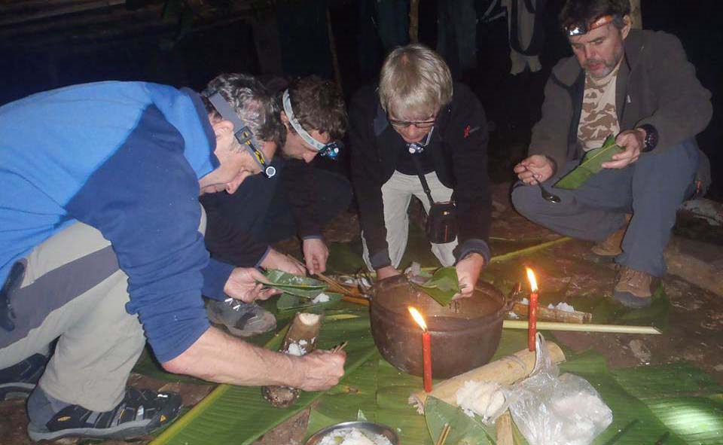
You will start by crossing the Namtha river hanging bridge into the rubber forests. For about 1 hour you will steadily climb through varieties of primary forest. Later this morning we will head deeper into the Namha protected area, where your local guide will share his personal experiences with you and teach you all about the poisonous and ediblle plants, local herbal medicines ( such as wild cardamoms, galangals, rattans, bamboo shoots) and how to watching Wildlife in the jungle.
After 3 hours of trekking you will arrive on the top of the mountain right around
lunchtime. There your will enjoy a traditional picnic lunch along the forest path gathered by your local guide.
After lunch you will still continue your journey through the thick forest and start collect forest edible plant for dinner together. You will arrive in the waterfall camp around 4 pm where you will spend the night. Your village guide will teach you how to build your own camp for the night, and cook rice in bamboo cylinders for dinner. And after dinner we have Lao whisky preparing from your local guide for enjoy with together around campfire. Fall asleep with the sounds of the forest (wild animals and the water stream around your camp).
Day 2:
7:00 AM: You will wake up, and the guides will already have prepared your breakfast and lunch for you. When the weather is good you might be able to see or hear the wildlife
9:30 AM: After breakfast you will start walking up-down through the NamHa national park another 4 hours and your local guide still show and share more his personal experiences with you and teach you all about the local herbal medicines and watching Wildlife on the way in the jungle. before stopping for a traditional lunch in the Lanten village. After lunch you will enjoy time with authentic people from the village come to visit and exchange life style of each. then continue your journey through the mountain with amazing views of the Hmong and Khmmu agriculture farm.
Your trekking will finish around 3 pm on the main road where a Tuk - Tuk will bring you back to the main city street.

Price:

Amount of People | 2 | 3 | 4 | 5 | 6 | 7 | 8
Price/Kip | 750.000 | 700.000 | 650.000 | 600.000 | 550.000 | 500.000 | 450.000
Price/dollar | 91 | 85 | 79 | 73 | 67 | 60 | 54

Where does your Money go?

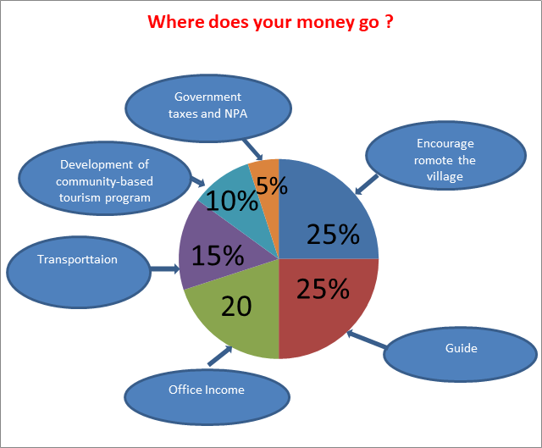

Things to Bring:
Please bring good walking shoes, long sleeve T-shirt, warm sweater, long pants, hat, sunscreen, mosquito repellents, camera,
medicines, snack food, and extra money.

Price includes:
Experienced guide, tour permit and village conservation fund, local government taxes, food, and first aid kit.

